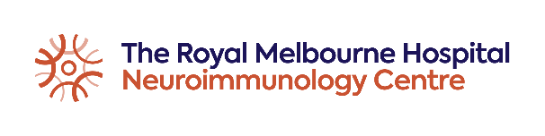
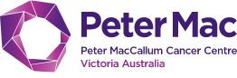
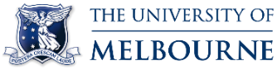

Neuroimmunology and CAR-T Fellowships
Royal Melbourne Hospital Neuroimmunology program in collaboration with Peter MacCallum Cancer Centre
The Royal Melbourne Hospital Neuroimmunology Centre is offering two 1-year fellowships in multiple sclerosis – with focus on (i) MS & neuroimmunology or (ii) MS & CAR-T cell therapy. The latter is offered in collaboration with the Peter MacCallum Cancer Centre (PMCC). The positions are accredited by the Royal Australian College of Physicians as non-core training in neurology.
The Royal Melbourne Hospital Neuroimmunology is an academic and clinical program providing care for over 1200 patients with a broad spectrum of neuroimmunological conditions. Our team consists of 9 neurologists, 2 neurology fellows, registrar, neuropsychologist, 2 neuropsychology fellows, 1 neuropsychiatry trainee, 4 research nurse coordinators, and visiting physiotherapist and social worker. The program includes laboratory, clinical, applied and outcome research streams. The Cellular Therapies Program at the PMCC is the largest program in Victoria offering CAR T-Cell therapy. In collaboration, the two programs are developing a framework for neurological and cognitive surveillance among patients undergoing CAR T-Cell therapy.
The two fellowships focus on management of MS and one of the focus areas: clinical neuroimmunology or neurological aspects of oncological conditions and therapies, in particular CAR T-Cell therapy. Weekly clinical load (approximately 50% of the fellowship time) consists of 1-2 MS/neuroimmunology outpatient clinics, 1 general neurology clinic, and either 1 neurology clinic at PMCC or neuroophthalmology clinic at RMH. The fellows participate in management of immunotherapy in the Day Infusion Centre (2-3 short safety infusion clinics). In approximately 50% of the fellowship time, the fellows will develop and pursue research projects within our established research streams, and will receive training in neuroimmunology – oriented clinical trials. The available research streams include:
- effectiveness and safety of therapies for neuroimmunological conditions
- diagnostics of neuroimmunological conditions
- neurological profiling of patients undergoing CAR T-Cell therapy
- assessment of neurotoxicity in treatment of oncological diagnoses
- objective clinical monitoring (including quantitative methods such as volumetric MRI and optical coherence tomography)
- myelin biology (in collaboration with The Florey Institute)
- basic neuroimmunology research (in collaboration with The Doherty Institute)
- biomarkers of treatment response (including immunological profiling)
- cognitive profiling (in collaboration with the Cognitive Neuroimmunology team)
- clinical outcomes research and biostatistics (in collaboration with CORe)
The fellowships are suitable for Australian or international applicants with valid registration in Australia. Preference will be given to applicants, who have completed core years of neurology training. For candidates with interest in building an academic clinical career, the fellowship can be extended into a PhD project.
Applications will open in April 2023 (https://melbournehealth.mercury.com.au/Default.aspx).
Enquiries: Tomas Kalincik, email: tomas.kalincik@unimelb.edu.au

